

**FACULTY OF COMPUTER ENGINEERING, INFORMATICS AND COMMUNICATIONS**

**DEPARTMENT OF COMPUTER SCIENCE**

**TITLE: DESIGN OF A WEB-BASED REAL-TIME DATA MANAGEMENT AND ANALYTICS PLATFORM. A CASE STUDY OF SCHEWEPPES ZIMBABWE LIMITED’S LOGISTICS OPERATIONS**

**NAME OF STUDENT: MARK MAGWEREGWEDE**

**REG NO.: R188837Y**

**SUPERVISOR: MR A. MURAMBA**

**THIS CAPSTONE PROJECT IS SUBMITTED IN PARTIAL FULFILMENT OF THE REQUIREMENTS FOR THE BACHELOR HONORS IN COMPUTER SCIENCE**

**DECEMBER 2024**

# Aknowledgements

I would like to express my deepest gratitude to my supervisor, Mr. A. Muramba for his guidance, encouragement and support throughout the course of this project. His insights and expertise were instrumental in shaping the direction of this work. I am also immensely thankful to my lecturers at the University of Zimbabwe, whose dedication to teaching and mentorship has provided me with the knowledge and skills necessary to undertake this project. Their commitment to excellence has inspired me to strive for the best in my academic journey. Finally, I extend my heartfelt appreciation to my family for their unwavering support, patience and encouragement.

# Abstract

This capstone project focuses on designing a web-based real-time logistics data management and analytics platform for Schweppes Zimbabwe Limited (SZL). This will replace the current inefficient, error-prone manual logistic management with a centralized automated platform. The system allows for real-time data logging, analytics, and visualization that shall be useful to distribution clerks, managers, and executives in decision-making. The transport logging, role-based access control, predictive analytics, and automated reporting will be integrated into the platform using an incremental development methodology. The platform’s design integrates modern technologies and data visualization tools to ensure scalability, security and usability.  
  
This research highlights the gaps in existing literature and systems particularly the lack of cost-effective and adaptable logistics solutions for developing economies. The project is expected to enhance operational efficiency, reduce costs and improve decision-making capabilities for SZL, demonstrating the potential of leveraging digital technology to optimize logistics operations.

# Dedication

I, MAGWEREGWEDE MARK (R188837Y), hereby declare that l wrote this document under the rules and regulations of the University of Zimbabwe Department of Computer Science. Any borrowed resources used have been fully acknowledged.

Author:______________________________________Date:______________________

The undersigned attest that they have read this project and that they have given it their approval for submission for marking after determining that it complies with the department's standards.

Supervisor: _________________________________Date:__________________

Table of Contents

Aknowledgements ii

Abstract iii

Dedication iv

List of figures viii

List of Tables viii

List of abbreviations ix

1 INTRODUCTION 1

1.1Context and Background 1

1.2 Problem Statement 1

1.3 Proposed Solution 2

1.3.1 System Tasks 2

1.4 Aim 3

1.5 Objectives 3

**1**.6 Justification and Relevance 4

**1**.7 Project Scope 4

1.8 Ethical Considerations 4

1.9 Project Cost 5

1.10 Project Plan 5

2. Literature Review 7

2.1 Introduction 7

2.2 Theoretical Framework 7

Information Systems Theory 7

Supply Management Theory 7

Lean Logistics 7

Transaction Cost Economics (TCE) 8

Technology Acceptance Model 8

2.3 Historical Context 8

2.4 Review of Present Implementations 8

Oracle Transportation Management (OTM) 8

SAP Transportation Management 9

Freightview 9

Project44 9

Descartes MacroPoint 9

Flexport 10

FourKites 10

Navisphere 10

2.5 Key Studies and Their Findings 11

2.6 Methodological Approaches 11

2.6.1 Qualitative Research 11

2.6.2 Quantitative Research 13

2.7 Gaps in the Literature 14

Focus on high-end solutions 14

Lack of focus on developing economies 14

Cost and implementation challenges 14

2.8 Controversies and Debates 15

All-in-one platforms versus modular platforms 15

High implementation costs 15

Data security and privacy 15

Job displacement 15

2.9 Synthesis and Evaluation 15

2.10 Conclusion 16

3. METHODOLOGY 17

3.1 Introduction 17

3.2 Research Methodology 17

3.2.1 Types of Data Collected 17

3.2.2 Data Collection Methods 17

3.2.3 Evaluation and Justification of Methodological Choices 18

3.2.4 Data Analysis Methods 19

3.3 Design Methodology 19

3.3.1 Justification for the Incremental Methodology 20

3.3.2 Incremental Development Phases 21

3.4 Resource Requirements 21

3.4.1 Hardware Requirements 21

3.4.2 Software Requirements 22

3.5 Functional & Non-functional Requirements 22

3.5.1 Functional Requirements 22

3.5.2 Non-functional Requirements 23

3.6 Modelling Diagrams 24

3.6.1 Use Case Diagram 24

3.6.2 System Architecture Diagram 25

3.6.3 Class Diagram 25

3.6.4 Object Diagram 26

3.6.5 Sequence Diagram 27

3.6.6 Communication Diagram 28

3.6.7 State Chart Diagram 29

3.6.8 Data Flow Diagram 30

3.7 Expected Outcomes and Impact 30

3.7.1 Success Criteria 30

3.7.2 Impact 31

3.8 Conclusion 32

References 33

# List of figures

Figure 1: Project Gantt Chart 6

Figure 2: Incremental design methodology 20

Figure 3: Use Case diagram 24

Figure 4: System Architecture Diagram 25

Figure 5:Class Diagram 26

Figure 6: Object diagram 27

Figure 7: Sequence diagram 28

Figure 8: Communication diagram 29

Figure 9: Truck driver Object State Diagram 29

Figure 10: Data Flow Diagram 30

# List of Tables

Table 1: Use Case diagram key 24

Table 2: Class diagram key 25

Table 3:Object diagram key 26

Table 4: Sequence diagram key 27

Table 5: Data Flow diagram key 30

# List of abbreviations

API – Application Programming Interface

ERP – Enterprise Resource Planning

ETA – Estimated Time of Arrival

FMCG – Fast Moving Consumer Goods

GPS – Global Positioning System

IoT – Internet of Things

IT – Information Technology

JIT – Just-In-Time

KPI – Key Performance Indicator

OTM – Oracle Transport Management

RBAC – Role-Based Access Control

RDBMS – Relational Database Management System

ROI – Return on Investment

SCM – Supply Chain Management

SZL – Schweppes Zimbabwe Limited

TAM – Technology Acceptance Model

TCE – Transaction Cost Economics

TMS – Transport Management System

UCD – User Centred Design

UML – Unified Modelling Language

# 1 INTRODUCTION

This chapter presents the project's concept and the set of problems that the project aims to solve. The chapter also details both the general and specific objectives that will guide its development. Additionally, it addresses the project's relevance and offers a brief overview of what to expect in the next chapters.

## 1.1Context and Background

Schweppes Zimbabwe Limited (SZL) is a Coca-Cola Company licensed manufacturer and distributor of noncarbonated still beverages. SZL is a subsidiary of Schweppes Holdings Africa Limited. The holding company also owns Beitbridge Juicing, the processing division that supplies orange fruit to SZL. Schweppes Zimbabwe Limited in turn manufactures and distributes Mazoe cordials, Minute Maid fruit juice and bottled water. SZL operates nine sites across Zimbabwe: Harare (head office), Bulawayo, Gweru, Mutare, Masvingo, Chinhoyi, Chiredzi, Victoria Falls, and Bindura. The noncarbonated still beverages are manufactured at the Harare and Bulawayo sites and then transported to the remaining seven operational sites which serve as depots with warehouse facilities and local distribution vehicles (Schweppes Zimbabwe, 2024).

SZL depends on external transport companies for logistics operations as they do not have their own fleet of trucks. This outsourcing arrangement allows for Schweppes to focus on the production of fruits and manufacture of beverages. Although external agents handle the logistics operations, Schweppes Zimbabwe has a supply chain department that oversees the movement of raw materials, capital goods and finished goods. This department is also responsible for organising the transport of these goods and keeps a record of logistics on paper. Distribution clerks are required to contact transport companies when there is a load that requires transport and record this into the transport logbook when the transporter comes to pick the load.

The distribution clerks are comfortable with this system as it is simple and straight-forward. This record keeping system is also significantly cheap as the only expense is stationery. When the current logbook is filled, it is placed in a file and the clerks begin logging in a new book. The main drawback of this system is that retrieving records becomes challenging over time as physical files accumulate and become difficult to organize. Additionally, this system depends on human capacity to observe trends and analyse transporter behaviour such as identifying which transporter is the fastest on a specific route. This reliance makes the analysis susceptible to bias and errors.

## 1.2 Problem Statement

Despite the advancement of technology, companies face significant challenges in managing logistics operations efficiently. Many businesses continue to use manual hard copy systems for their logistics management, leading to inefficiencies and errors. This reliance on paper-based processes results in fragmented data sources since the data is not centralized making it difficult to achieve real-time visibility and coordination among stakeholders (Harrison and van Hoek, 2011).

Manual systems are prone to human error such as data entry mistakes and misfiling which can compromise the accuracy of logistics information (Wang et al., 2016). Additionally, retrieving and sharing hard copy documents can be time-consuming. Consequently, these businesses are unable to derive essential data-driven insights critical for continuously optimising key performance indicators such as productivity, efficiency, lead times, operational costs, revenue, and safety. As a result, a business may encounter increased transportation costs and delays which negatively impact operations and overall profitability (Christopher, 2016).

Furthermore, the inability to analyse vast amounts of logistics data effectively in a manual system hinders businesses from identifying trends and forecasting demand (Kumar and Singh, 2019). This lack of insight can be detrimental to the company as it results in supply chain disruption, consumer dissatisfaction and possibly reduced market share in the long run.

SZL lacks a comprehensive web-based platform that integrates real-time data management and data analytics in its logistics. Without such a solution, SZL is unable to harness the full potential of their logistics operations leading to missed opportunities for optimization and strategic improvement (Mentzer et al., 2001).

## 1.3 Proposed Solution

Electronic data processing began in the 19th century and has significantly transformed how businesses operate, enhancing both efficiency and accuracy. Computers also found a place in the logistics industry and are used primarily for inventory control and order processing. However, the use of computers in logistics is below its optimum as there are emerging technologies that are yet to be fully utilized in this industry. One such technology is data analytics. Fiveable.me (2024) defines data analytics as the process of examining datasets to draw conclusions about the information they contain in order to enable organizations to make informed decisions based on empirical evidence.

Supply chain management requires efficient processes in order to streamline logistics operations. The design of a web-based real-time logistics data management and analytics platform has been proposed to address the challenges faced by businesses in tracking, managing and analysing their logistics operations. The web-based application will serve as a centralized hub, enabling relevant SZL stakeholders to access real-time data and make informed decisions promptly. By integrating data analytics, the system will offer valuable insights into operational efficiencies, inventory management and transportation logistics.

### 1.3.1 System Tasks

#### Transport logging in real-time

The system will allow clerks to log trucks and related details such as origin, destination and product dispatched. This data should be accessible for data analysis as soon as it is entered into the system. This data should also be retrievable and easily categorised with respect to time, transporters and other categories.

#### Data visualisation

The system will show visualisations for data captured in the system. The system will be able to present the data in charts such as bar graphs and heatmaps. This will enable stakeholders to get an overview of the data at a glance.

#### Real-time data analysis

Data in the system can be analysed by the system to offer insights into the data such as fastest transporter over a route and frequency of product transportation. These insights will enable the company to allocate resources efficiently and predict the demand of its product.

#### User role management

The system should employ a role-based access control (RBAC) system. The system will assign users to roles and each role will have specific permissions associated with it. By restricting access based on roles, the principle of least privilege will be upheld and this reduces the risk of unauthorized access.

#### Reporting

The system should be able to generate reports that can be used to provide detailed statistics. These reports will be sent regularly to relevant SZL stakeholders via electronic mail in order for them to review their logistics operations.

As companies increasingly rely on data-driven strategies, the proposed platform will not only enhance visibility across the supply chain but also foster collaboration among various stakeholders in different locations. The ultimate goal is to improve overall service delivery, reduce costs and consequently position businesses to thrive in a competitive market.

## 1.4 Aim

This project aims to develop a web-based real-time logistics data management and analytics platform for SZL. This application will streamline logistics processes by digitalizing data entry, retrieval and reporting thereby reducing reliance on manual hard copy systems. This will enhance operational visibility, improve decision-making capabilities and ultimately contribute to the profitability of the business.

## 1.5 Objectives

The project has the following objectives to achieve the aim of developing a Web-based Real-time Logistics Data Management and Analytics Platform:

1. **System Design and Development**: Create a user-friendly interface and robust backend architecture to support real-time data processing and storage.
2. **Analytics Dashboard**: Design an interactive analytics dashboard that visualizes key performance indicators (KPIs), trends and patterns in logistics operations.
3. **Reporting**: Integrate the generation of reports on set timelines that can provide more insight to stakeholders.
4. **User Access Control**: Establish role-based access controls to ensure that sensitive data is protected while allowing relevant stakeholders to access necessary information.

## **1**.6 Justification and Relevance

The world is increasingly embracing digital technologies in every area of life. Developing a web-based logistics management platform for SZL aligns with this trend and will enable the business to leverage digital tools for improved performance and competitiveness (Bhimani, 2019). Moreover, as logistics operations at SZL generate vast amounts of data, a digital platform is essential for managing and analysing this data effectively. Organisations that harness big data analytics can gain a notable advantage (Gonzalez et al., 2016). The logistics data management and analytics application will provide stakeholders with immediate access to logistics data and integrating analytics tools allows organisations to analyse historical and real-time data to identify trends and make forecasts. This data-driven approach supports better resource allocation and has become essential since it empowers companies to maximize their levels of efficiency (Frankenfield, 2023).

Without the web-based application, SZL cannot extract data-driven insights from its logistics operations data. As a result, the business's logistics operations will not function optimally.

## **1**.7 Project Scope

This project will be developed for:

* **Business Executives**: Oversee operations and require data insights to make decisions.
* **Logistics Manager:** Monitor input data and manage clerks’ user accounts.
* **Distribution Clerks:** Input logistics data into the system.

The following will be excluded from the project:

1. Development of a mobile application for the system will not be included.
2. Connecting the system with other business applications will be out of scope.
3. Use of GPS to track trucks on the move

## 1.8 Ethical Considerations

When creating a web-based logistics data management and analysis system, ethical issues will be kept in mind. First, the project will protect users' data privacy and security by using strong safeguards and following all relevant laws. Transparency is also important as users should know how their data is used and give their informed consent. It is crucial to establish accountability by clearly defining who is responsible for managing the data and how users can report any misuse. The project will also pay attention to bias and fairness. This means regularly checking algorithms to avoid discrimination and designing the system to be inclusive for all types of users.

## 1.9 Project Cost

The project is expected to incur the following direct costs:

* Web hosting
* Testing and quality assurance
* Training

The project is expected to incur the following indirect costs:

* Internet services for research
* Stationery used during course of the project
* Transport and communication costs incurred during research and obtaining feedback from users.

## 1.10 Project Plan

This project is expected to span a period of four months, starting September 2024 to December 2024. At the end of this period, the project and its associated documentation should be complete. The project is required to go through these development stages:

#### Analysis

Studying the current systems during this stage will help to clarify the needs for the suggested system. The researcher will define the problem he wants to solve at this phase and in order to determine the needs of the user and the system, the researcher will employ a range of information collection strategies.

#### Design

After the fact-finding and analysis stage, the design phase follows. This stage requires a detailed specification of the proposed system. The researcher will also design database architecture, user interface and the overall system layout.

#### Implementation and Testing

At this stage, the researcher will code the application based on the design specifications and conduct testing on the newly developed system. Feedback from users is also considered and the necessary adjustments made.

Figure 1 outlines the timeline for all project activities and will be used by the researcher to track and monitor their timely completion.



Figure 1: Project Gantt Chart

2. Literature Review

2.1 Introduction

Real-time logistics data management and analytics platforms have become essential as businesses seek efficient ways to optimize and monitor supply chains. For companies such as SZL, logistics operations rely on hard copy records which pose significant challenges in terms of efficiency, accuracy and scalability. In contrast, web-based logistics data management platforms automate data entry and provide real-time analytics, significantly enhancing operational performance. This literature review provides insights into current offerings, their adaptability to different logistics needs and considerations for developing a web-based platform tailored to effective logistics data management. The need for continuous improvements and specific business-oriented customizations in logistics technology continues to drive research and development in this area (Alder & Sidhu, 2020).

2.2 Theoretical Framework

The theoretical framework for the use of real-time web-based data entry and analysis in logistics operations is rooted in a number of theories and models.

Information Systems Theory

This theory highlights the role of information systems in improving decision-making through the efficient management of data. A key concept of this theory is that data is a critical resource that drives decision-making. The availability of accurate and real-time logistics data is essential in optimizing operations and forecasting demand in a company like SZL (Kroenke & Boyle, 2017; Liu et al., 2022). A web-based logistics platform provides real-time data collection and analytics therefore leading to better-informed decisions and optimized resource allocation.

Supply Management Theory

The development of a real-time logistics platform is rooted in supply chain management (SCM) theory. SCM theory emphasizes efficiency, reliability and transparency across logistics operations. This aligns with the principles of Just-In-Time (JIT) logistics. These principles emphasize the reduction of excess inventory and meeting real-time demand through streamlined processes (Chen et al., 2019). Real-time data allows logistics companies to address disruptions dynamically and therefore meeting the theoretical goals of SCM to enhance responsiveness and minimize delays.

Lean Logistics

Lean Logistics is derived from lean manufacturing principles and has primarily been popularized by Toyota’s production system. Lean principles emphasize the reduction of waste and align well with the benefits of digitalisation. Web-based platforms reduce these inefficiencies by improving data flow and eliminating redundancies (Womack & Jones, 1996; Kang et al., 2020). In the context of implementing a web-based system, lean principles highlight how a web-based logistics data management application can result in the reduction of waste and inefficiencies.

Transaction Cost Economics (TCE)

Web-based systems decrease transaction costs due to the time and labour saved in the process of recording, retrieving and analysing data (Williamson, 1981). Transaction costs include costs of searching for information, negotiating contracts, monitoring performance and enforcing agreements. In digital systems, these costs are lowered because there are less delays in data availability and consistent record-keeping. Williamson (1981) further stresses that companies should lower transaction costs and reduce the risks associated with human error. Automated data entry and real-time analytics reduce these transaction costs by streamlining operations.

Technology Acceptance Model

The Technology Acceptance Model (TAM) is a well-known theory that states that perceived utility and simplicity of use have an impact on the adoption and use of a system. The model put forward that employees are more likely to accept a web-based system if they believe it to be convenient and easy to use (Davis, 2019). In support of this model, I intend to design a web-based data management application for the distribution department at SZL that will contain a user-friendly interface but will also have functionality that will enable the relevant stakeholders to make inferences from the data and in turn make decisions based on these inferences.

2.3 Historical Context

Historically, logistics operations relied on manual data entry and record-keeping. This method was widely implemented due to its low cost and simplicity. However, as global supply chains became more complex, manual systems began to struggle with the volume and speed of information required. The widespread adoption of digital technologies such as cloud computing and the Internet of Things (IoT) enabled the development of automated logistics systems capable of handling larger volumes of data in real-time (Zhong et al., 2017; Bechtsis et al., 2021).

The evolution of logistics platforms began with simple Transportation Management Systems (TMS) in the late 20th century. Initially, TMS solutions were limited to tracking fleet movements and managing simple route optimizations (Berfield, 2018). By the early 2000s, advancements in cloud computing and Global Positioning System (GPS) technology enabled real-time tracking and more complex data integrations, leading to today’s multi-functional platforms that cover everything from routing and shipment status updates to predictive analytics (Singh, 2021).

2.4 Review of Present Implementations

There are several implementations of commercial real-time logistics platforms with each of them incorporating unique functionalities, strengths and limitations:

Oracle Transportation Management (OTM)

OTM provides a comprehensive transportation management solution that covers route planning, carrier management and real-time analytics. It offers seamless integration with other Oracle solutions which is primarily beneficial to companies that use Oracle ERP systems. OTM has robust scalability and is therefore suitable for large companies. OTM’s wide-ranging functionality includes transportation scheduling, tracking and analytics that provide data insights through rich reporting and customizable dashboards. However, the initial setup is complex and expensive. This complex setup also requires extensive user training which takes time from business operations. OTM is also known for high licensing fees and additional implementation costs that depend on usage and scale. Consequently, this solution is best suited for large enterprises with complex logistics operations that need seamless integration with other ERP solutions.

SAP Transportation Management

SAP’s platform focuses on managing both inbound and outbound logistics with emphasis on network optimization and compliance. As a highly rated integrated system, it works well with SAP’s ERP suite to support broad business operations but has limited flexibility with non-SAP systems (SAP, 2022). SAP has robust analytics and compliance tools which makes it suitable for large enterprises with intricate compliance needs. On the other hand, SAP has a steep learning curve for new users which requires extensive time to maximise productivity. SAP follows a modular pricing approach and licensing fees are based on usage and features. As a result, there are high costs involved in using the application especially when integrated with other SAP applications. SAP Transport Management is best suited for large companies that have already invested in SAP infrastructure and those that require high levels of security and compliance.

Freightview

Freightview is a simpler, cloud-based transport management system (TMS) platform with a focus on freight cost optimisation and shipment tracking for small to mid-sized businesses. Freightview can compare rates from multiple carriers to find cost-effective options. This TMS also monitors shipments in real-time and provides alerts for status updates. This application simplifies freight management with an easy-to-use user interface. Freightview has lower costs when compared to ERP systems that make it ideal for smaller logistics setups prioritising cost savings and ease of use. Conversely, it lacks advanced predictive analytics which limits its utility (Freightview, 2023).

Project44

Project44 specialises in real-time visibility with an extensive network of Application Programming Interface (API) integrations that support multi-modal tracking with multiple carriers across land, sea and air. This platform provides real-time tracking and high-level visibility but lacks broader TMS functionalities such as data analytics and reporting which is restrictive for companies looking for all-in-one solutions (Deloitte, 2021). Project44 TMS is suitable for businesses that prioritise visibility.

Descartes MacroPoint

Descartes MacroPoint is notable for freight visibility and predictive analytics. The platform is able to integrate with many TMS solutions and offers real-time updates on shipment status. This is particularly beneficial to companies with diverse shipping needs (Descartes, 2022). Although it is a strong contender when prioritising tracking, it is best employed when paired with a comprehensive TMS as it lacks standalone end-to end transportation management features such as transport planning, route optimization and carrier management. (Chen et al., 2019).

Flexport

Flexport provides end-to-end visibility of shipments across various modes of transportation and is able to integrate data from multiple sources. The platform features an intuitive dashboard that simplifies the logistics process for users. Flexport has a strong international presence and this makes it suitable for businesses that operate on a global scale. However, some users have reported that Flexport’s services can be expensive as compared to other logistics platform providers. Moreover, even though it offers a wide range of features, some businesses may find the platform less customizable than other solutions. Flexport is best suited for companies engaged in international shipping.

FourKites

FourKites is a logistics data management platform that excels in visibility and tracking of shipments across various transportation modes, providing accurate Estimated Time of Arrival (ETA). The platform also uses advanced analytics and machine learning to offer insights into supply chain performance and these aid businesses in optimizing logistics operations. An advantage of this system is that it integrates well with various TMS and ERP solutions, allowing seamless dataflow. On the other hand, the platform’s extensive features can be overwhelming especially for smaller teams with less experience in logistics technology. FourKites is best suited for businesses that require extensive tracking and visibility into their supply chain and especially those with large volumes of shipments and complex logistics networks. It can be particularly beneficial to the fast-moving consumer goods (FMCG) and retail industries.

Navisphere

Navisphere is a comprehensive platform by C.H Robinson that combines transportation management, visibility and analytics. Businesses can leverage C. H. Robinson’s extensive carrier relationships to get a broad range of transportation options. The platform also offers wide-ranging user support and training resources which help users to maximise the benefits of the system. Conversely, the user interface has been reported to be less intuitive than competitors and some businesses report facing challenges when attempting to connect Navisphere with their existing Information Technology (IT) infrastructure. This platform is mostly suited to enterprises already using some of C. H. Robinson’s services.

It is clear that each platform has strengths that meet specific logistical needs. OTM and SAP are well-suited to large organizations with complex logistics demands due to their comprehensive functionalities and ERP integrations. However, they are costly and require extensive training for effective use. In contrast, Freightview offers a cost-effective solution for smaller companies but lacks the predictive analytics required by larger operations. Platforms like Project44 and Descartes MacroPoint serve niche needs with strong tracking and visibility features though they lack full TMS capabilities (Freightview, 2023; Singh, 2021). Other platforms also serve niche needs such as Flexport which is focused on international shipping and FourKites which focuses on large volume shipments which have complex supply chains. Navisphere is ideal for businesses seeking a holistic approach to supply chain management, with extensive carrier options and robust support, but it may require some adaptation to its interface.

2.5 Key Studies and Their Findings

Recent studies also emphasize the benefits associated with automated, web-based platforms:

Yu et al. (2021) found that automated data entry systems decreased operational errors by 30% and resulted in reduction of delays in decision-making. The study highlighted the role of real-time analytics in providing predictive insights that reduce costs and improve supply chain responsiveness. In addition, Christopher (2016) supports this view and highlights that digital data entry in logistics will result in reduced delays, data inaccuracies and operational costs. His research emphasizes the benefits of moving to digital platforms to eliminate errors and reduce processing times.

Kang et al. (2020) found that automated data systems greatly improved warehouse operations particularly in demand forecasting and inventory management. Companies that continued using manual systems faced significant competitive disadvantages in industries with high data volumes. Furthermore, Ding et al. (2021) found that companies using computerised data entry systems achieved improved logistics performance particularly in the areas of route optimization, warehouse management and demand forecasting. These companies also benefited from higher data accuracy, allowing for more reliable analytics and forecasting.

Liu et al. (2022) studied companies transitioning from manual systems to automated platforms in developing countries and discovered that while the upfront costs of computerisation are high, companies quickly recoup these costs through improved operational efficiency, reduced labour and better data accuracy.

2.6 Methodological Approaches

Researchers in the real-time web-based data logistics management space have applied various research methodologies to obtain information that can contribute to the functionality, scalability and user experience of these applications.

2.6.1 Qualitative Research

*Interviews*

Flexport conducted extensive interviews with focus groups such as shippers and warehouse managers to understand industry challenges and this resulted in the development of a platform that integrates end-to-end tracking with customs management. The research identified key points such as the need for integrated data visibility across all transportation modes (Flexport, 2020). Baskerville et al. (2015) emphasized the importance of interviews and focus groups in logistics systems. Interviews with logistics personnel can uncover specific requirements that are essential.

Liu et al. (2022) also used interviews with logistics professionals to understand the perceived benefits of automation and the practical challenges of manual systems. This method is particularly useful when examining the challenges faced by companies transitioning from manual to automated systems or adopting new technologies such as real-time analytics.

Interviews provide detailed insights into participants thoughts, feelings and experiences by capturing individual perspectives. The interviewer is able to build rapport with the participant and thus increasing trust and encouraging openness. Interviewers can then further probe participants with follow up questions so as to get clarity on a certain answer. However, this approach is time-consuming and resource intensive. The interviewer can also introduce bias by suggesting answers to participants. Furthermore, interviews usually have a small sample size and thus there is limited generalizability.

*Observation*

FourKites researchers used observation in logistics settings to identify bottlenecks in freight visibility and tracking. By observing logistics managers’ interactions with freight tracking systems, they were able to identify the need for real-time location tracking and predictive ETAs which led to innovations in their real-time visibility platform (FourKites, 2021). Direct observation of logistics workflows is essential for logistics research as it can reveal inefficiencies and potential for improved processes. This approach is especially valuable in logistics, where observing processes provides insights into real-time data requirements and workflow bottlenecks (Deng et al., 2018).

Observations provide unbiased and objective data on behaviours and practices and capture the context and environment in which these behaviours occur. Observations also reveal unspoken norms and practices such as system bypasses. However, observations may be unproductive as they require significant time and resources. Observations also raise ethical concerns about participant consent and privacy. Moreover, observations may not be representative of the entire population.

*Comparative case studies*

Yu et al. (2021) and Bechtsis et al. (2021) compared companies that use real-time logistics data management platforms with those that still use manual systems. These studies provided detailed insights into improvements in accuracy, time savings and overall supply chain performance.

The case study approach allows for a deep understanding of the specific challenges and benefits that businesses experience when implementing digitalisation. This deep understanding provides practical insights that can be applied by businesses in similar industries. However, since case studies focus on specific examples, the findings might not be universally applicable. Moreover, case studies often rely on a small sample size which might not be representative of the whole population and thus introduce bias.

*User-centred design (UCD) research*

Oracle leveraged UCD principles to refine its OTM platform by using prototypes tested with end-users across various industries. Through iterative feedback, Oracle improved the platform’s interface and usability for logistics roles such as carrier managers and inventory controllers. This ensured alignment with the needs of the diverse logistics stakeholders (Oracle, 2020)

FourKites also developed user personas based on focus group findings to guide their platform design. Personas included roles like logistics coordinators, operations managers and drivers. This helped the design team create a user interface tailored to specific needs such as simplified data visualisation and mobile accessibility for on-the-go staff (FourKites, 2021)

UCD helps to build systems that match user needs. Norman & Draper (1986) showed that persona development and early prototyping significantly improve system usability and user satisfaction. This is especially applicable since usability can directly impact operational efficiency. The drawback of UCD is that it is resource and time extensive since it requires iterative feedback from the user community.

2.6.2 Quantitative Research

*Surveys*

Surveys were used by researchers at Project44 to quantify customer preferences for features such as live tracking, data security and automated reporting. This data-driven approach helped prioritize features that significantly improve operational efficiency and lead to the development of robust APIs for real-time data connectivity and actionable analytics (Project44, 2019). Surveys provide measurable insights into user expectations and are often used in conjunction with data analysis to quantify the demand for specific features (Zikmund et al., 2013). This method is well-suited to logistics platforms where understanding data usage and feature prioritisation can impact system design. In addition, data-driven analysis is vital in identifying process inefficiencies and predicting system requirements in logistics (Chen et al., 2019)

Kang et al. (2020) used quantitative models to simulate the impact of an efficient real-time logistics platform on logistics performance metrics such as error rates, delivery times, and operational costs. Zhong et al. (2017) employ quantitative methods including surveys and statistical analyses, to measure the effectiveness of logistics automation and real-time data systems. These studies often involve large datasets and the use of statistical tools to analyse relationships between variables such as automation, efficiency and error reduction.

Preference to surveys is due to the large and representative samples that can be collected. Surveys are also relatively inexpensive especially nowadays when they can be conducted online. Another advantage is that surveys provide quantitative data that can be used for statistical analysis so as to get inferences from the data. This is because surveys ensure standardised questions and thus ensure consistency. On the other hand, surveys have limited depth and provide shallow insights that lacks context because the researcher may get the statistics but fail to understand why that is the outcome. There is also an issue of response bias, where participants may provide socially desirable or even incomplete responses.

*Market Analysis*

In order to stay competitive, C.H. Robinson benchmarked their logistics platform, Navisphere, against competitors like Oracle TMS and SAP. They analysed their features, costs and limitations and highlighted the importance of predictive analytics and customizable reporting. This market analysis influenced Navisphere’s development to offer real-time visibility, automated updates and customizable dashboards (C.H. Robinson, 2019). Benchmarking against other real-time logistics platforms reveals feature gaps and industry best practices. This helps to shape unique system attributes. This approach has been extensively discussed in research as essential for identifying gaps and differentiation points in competitive logistics systems (Håkansson & Snehota, 2017).

A positive aspect of market analysis is that it identifies market trends, competitor activity as well as revealing industry best practices. Market analysis also plays a role in strategic decision-making by providing information that can be acted upon for better market performance. The shortcoming of market analysis is that it focuses on existing markets and competitors and may overlook emerging trends that determine where the industry is advancing to.

2.7 Gaps in the Literature

Several gaps remain in the research on the implementation of web-based logistics data management and analytics platforms:

Focus on high-end solutions

Research on logistics platforms primarily addresses high-end solutions and this leaves a gap in the literature around scalable, adaptable and cost-effective platforms. Furthermore, the literature lacks comprehensive insights into user customisation capabilities and the long-term return on investment (ROI) for the various platforms.

Lack of focus on developing economies

Most studies focus on logistics operations in developed countries. Research on the use of web-based logistics data management and analytics platforms by companies in developing countries such as Zimbabwe is limited, especially when considering factors such as infrastructure and cost barriers (Zhou & Wang, 2021).

Cost and implementation challenges

More research is needed to explore the cost-effectiveness of implementing automated logistics platforms, particularly for businesses with limited budgets or those operating in regions with poor digital infrastructure (Yu et al., 2021). Furthermore, while the technical advantages of automated systems are well-documented, there is limited research on the human and organizational barriers to adopting these systems, particularly in contexts where employees may be resistant to change.

While there is a growing body of literature on web-based logistics data management platforms, there is a deficit of research focused on the implementation of these systems in developing countries as well as the impact of the transition from manual systems on the employees in these companies. This gap presents an opportunity to weigh in on existing research by conducting this case study and highlights a need for research on platforms designed for operators who may have different technological and operational requirements. This will in turn provide valuable insight and recommendations to similar companies looking to utilise to web-based applications.

2.8 Controversies and Debates

Several debates exist in the discussion on the utilisation of web-based logistics data management and analytics platforms:

### All-in-one platforms versus modular platforms

Chen et al. (2019) discuss that the logistics industry debates between using all-in-one proprietary platforms and modular API-based platforms that allow for third-party integrations. While all-in-one platforms provide streamlined functionality, they often come with high licensing costs and limited flexibility. On the other hand, API-based solutions offer integration flexibility but may face interoperability challenges when connecting with legacy systems. The debate remains open as to which model better supports diverse logistics needs and adapts to rapid technological changes.

High implementation costs

Critics argue that the high upfront costs of computerisation may not be justifiable for smaller companies, especially in developing regions (Liu et al., 2022).

Data security and privacy

With web-based platforms, companies face increased risks of data breaches and cyberattacks. Managing these risks while maintaining operational efficiency is a significant challenge (Bechtsis et al., 2021).

Job displacement

Computerisation reduces the need for manual labour, raising concerns about potential job losses for administrative and logistics staff (Ivanov et al., 2020).

2.9 Synthesis and Evaluation

The literature reveals that real-time logistics data management and analytics platforms are key to logistics operations as they improve data accuracy and analysis. This has a direct impact on the operational efficiency of logistics operations. The existing literature also establishes that each platform has strengths that meet specific logistical needs.

However, these platforms are either comprehensive and costly or they are affordable but lack full TMS capabilities. This implies that enterprises are required to make a trade-off without a fully customisable alternative available. There is also the high-cost implementation associated with real-time logistics data management platforms. In addition, these platforms raise data security and privacy concerns. Companies risk data breaches that can disclose sensitive data. Despite these issues, the long-term benefits of computerisation such as increased competitiveness, reduced operational costs and enhanced scalability make the adoption of web-based platforms crucial for businesses to remain competitive in the global market.

Considering the available solutions, this project will build on existing implementations by offering a middle ground between expensive, comprehensive systems and basic solutions by focusing on flexibility, scalability and affordability. The proposed platform will provide core functionalities in real-time data management and analysis, bridge existing gaps in the market and empower companies to enhance their logistics operations effectively and affordably.

2.10 Conclusion

The existing literature reveals that while many real-time logistics management platforms provide valuable functionalities, there remains a need for more a flexible, adaptable and cost-effective solution. There also exists a gap as most platforms provide high-end solutions with limited focus on developing economies where the digital infrastructure is not as advanced. As the relationship between data analytics and the logistics industry grows, demand for user-customizable platforms that balance cost with functionality will likely drive innovation in this field.

# 3. METHODOLOGY

## 3.1 Introduction

The methodology outlines the approaches used in the research and design of a real-time web-based logistics data management and analytics platform for Schweppes Zimbabwe. The research methodology discusses the type of data collected, the data collection methods, the data analysis techniques, and the justification for the chosen methods. In software development, a system development methodology refers to the framework that is used to structure, plan and control the process of developing an information system. Software development methodologies define the processes we use to build software. These methodologies are also referred to as Software Development Process Models.

## 3.2 Research Methodology

A mixed-method approach is adopted that combines quantitative and qualitative data to ensure a comprehensive understanding of the logistical needs and constraints faced by SZL. Quantitative data provides numerical insights into logistics patterns, efficiency and performance metrics while qualitative data offers a contextual understanding from the perspectives of key stakeholders such as distribution staff, managers, and executives.

### 3.2.1 Types of Data Collected

#### Quantitative Data:

* Metrics on truck movements such as frequency and time taken for each route.
* Efficiency ratings of different trucking companies based on historical data.

#### Qualitative Data:

* Insights from interviews with distribution staff, managers and executives.
* Observations on current challenges with manual data entry and specific user requirements for the platform.
* Industry and company reports to gain an understanding on how other enterprises handle logistics operations.

This data can be classified into:

* Primary Data: Firsthand data collected directly from Schweppes' distribution and logistics processes, including observational data and feedback from current system users.
* Secondary Data: Industry reports, academic literature and case studies on similar logistics management platforms to understand best practices, system functionalities and performance benchmarks.

### 3.2.2 Data Collection Methods

An array of data was collected from the relevant stakeholders. The stakeholders are distribution clerks, distribution managers and SZL business executives. Data was also extracted from truck drivers as the system will also capture data from them.

#### Interviews

Semi-structured interviews were conducted with distribution staff, managers and executives at Schweppes. This method gathered detailed insights into the current logistics process, challenges faced by different user roles and specific features or metrics required for effective logistics management. The qualitative data obtained through interviews provided a foundation for designing the user interfaces and functionalities of the platform.

#### Questionnaires

Structured questionnaires were carried out to collect quantitative data on logistics-related metrics such as delivery timeframes, route completion rates and incident frequency for each transport company. These metrics are critical for assessing the operational efficiency of various trucking companies. The questionnaires also captured user preferences and expectations for system performance and usability.

#### Document Analysis

Existing logistics records at SZL were analysed to obtain quantitative historical data such as route performance, trucking company frequency and efficiency. This secondary data provided a benchmark for the metrics that the platform would track and allowed for a comparison between the current and future system efficiency.

#### Observational study

The current logistics processes were observed in real time to identify inefficiencies, data entry errors and potential points of failure. This direct observation provided contextual insights into the workflow in which the real-time web-based logistics data management and analytics platform would operate on.

### 3.2.3 Evaluation and Justification of Methodological Choices

#### Mixed-method approach

By combining quantitative and qualitative data, the researcher was able to obtain a comprehensive view of both logistical metrics and stakeholder perspectives. The quantitative data provides measurable indicators of logistics efficiency while qualitative insights ensure that the platform design meets the practical needs of its users.

#### Primary and secondary data

Collecting primary data through observations, interviews and surveys ensured that the developed platform will be tailored to SZL's specific logistics environment. Secondary data from industry records and similar case studies served as a benchmark which helped to align the platform with best practices in logistics data management.

#### Interviews

Interviews enabled an in-depth exploration of user requirements which are particularly valuable in a complex logistics environment with diverse roles.

#### Quantitative analysis

Using descriptive statistics analysis on historical logistics data provided a foundation for understanding current logistics efficiency levels and identifying improvement areas. Quantitative analysis also allowed for comparison and performance monitoring of different trucking companies which directly supports executive decision-making.

This methodological approach ensured that the platform will be both data-driven and user-centred. Furthermore, it confirmed the functional needs of the distribution staff, managerial requirements for oversight and executive demands for strategic logistics planning. The mixed methods approach leveraged comprehensive data sources and created a foundation for a platform that enhances logistics efficiency and decision-making.

### 3.2.4 Data Analysis Methods

#### Quantitative Analysis

The researcher collected numerical data which was analysed using descriptive statistics. Descriptive statistics provided a summary of key logistics metrics such average time per route and trucking company efficiency. Time series analysis was used to track trends over time such as route performance and seasonal variations in truck movements. The quantitative analysis enabled performance benchmarking and comparison across different trucking companies which will support decision-making on route efficiency.

#### Qualitative Analysis

Qualitative data from interviews and researcher observations was analysed and identified recurring themes and insights related to platform usability, efficiency requirements and process bottlenecks. The feedback was categorised to perform systematic examination of user needs and expectations which informed platform design and functionality prioritisation.

## 3.3 Design Methodology

The design process of a real-time web-based logistics data management and analytics platform for SZL requires the adoption of an appropriate software development methodology that balances flexibility, speed and functionality. The incremental method is an agile approach to software development and is particularly suitable for this project as it allows for iterative delivery of software components, continuous feedback and adjustment based on the evolving needs of stakeholders.

The incremental method divides the development process into smaller and manageable units or increments. Each increment is focused on building and delivering a specific functionality or feature of the system. These increments are developed and tested in iterations with feedback from stakeholders informing the design of the next increment.

This approach contrasts with the traditional waterfall model, where the system is developed as a single solution. The incremental method offers more flexibility by allowing parts of the system to be deployed and used while others are still under development. Figure 2 shows the incremental development methodology

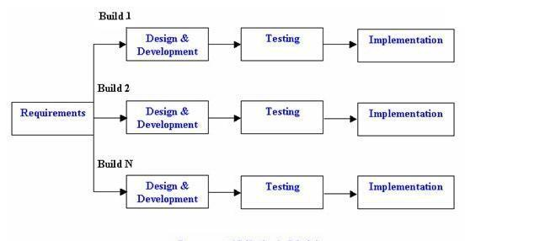

Figure 2: Incremental design methodology

### 3.3.1 Justification for the Incremental Methodology

#### Flexibility and Adaptability

The logistics sector involves dynamic conditions such as changing truck routes and logistical challenges. With incremental development, features such as route optimization and executive decision-making tools can be iterated upon based on the immediate feedback from stakeholders. In addition, the platform will be used by different roles with unique needs and workflows. The incremental method allows for these stakeholders to interact with the platform early on and provide feedback that can be integrated into the next development cycle.

#### Faster time to Market

By breaking down the project into smaller increments, critical features such as data logging and basic analytics can be deployed sooner. This provides early value to SZL and allows the company to begin using the platform's core functionalities while additional features are developed.

#### Continuous improvement

As the platform is developed in increments, each iteration allows the developer to refine existing features based on real-world usage. For instance, managers may identify additional metrics they wish to track for monitoring clerks or business executives may request more advanced analytics for decision-making. These adjustments can be incorporated into the next set of increments thus ensuring that the platform continuously improves over time.

#### Scalability

With the growing complexity of logistics management as Schweppes Zimbabwe Limited expands its operations, the platform must be able to scale. The incremental methodology allows the developer to gradually build the platform's capabilities to ensure that it can accommodate additional users and expanded analytics tools over time.

#### User-centred design

The incremental development method’s iterative nature allows for frequent user involvement. By releasing early versions of the platform, the distribution staff, managers and executives can provide direct input into the system’s usability and performance. This approach ensures that the final product meets the specific needs of SZL’s logistics operations.

### 3.3.2 Incremental Development Phases

#### i) Initial planning and Core features

The first increment will focus on essential logistics tracking functionalities such as logging truck movements and providing basic reports for managers. This will be the foundational phase of the platform which allows the staff to begin using the system.

#### ii) Manager and Executives’ dashboards

The next increment will focus on developing more sophisticated dashboards for managers and executives. These would provide real-time monitoring of clerks, truck efficiency and route performance. Feedback from these users will be incorporated to refine these features in the subsequent increment.

#### iii) Analytics

The next stage will introduce more advanced analytics which allow business executives to assess trucking company performance and make data-driven decisions. Continuous iteration based on feedback will fine-tune these functionalities.

#### iv) Optimisation and scaling

The final increment will focus on optimizing the platform's performance to ensure it can scale to handle larger amounts of data and users as SZL’s operations grow. This could include advanced optimization algorithms for route planning and load balancing on cloud servers.

## 3.4 Resource Requirements

In order to effectively implement the real-time web-based logistics data management and analytics platform, the hardware and software requirements are specified.

### 3.4.1 Hardware Requirements

#### Server

A high-performance server is essential to handle real-time data processing, storage and retrieval. Use of cloud-based servers from cloud service providers such as Microsoft and Amazon are the most effective approach. This is because cloud-based servers are cheaper than physical servers, more reliable. Cloud servers are also favourable due to their scalability which helps accommodate varying loads without requiring significant initial investments (Ramirez et al., 2018). Cloud-based servers reduce initial costs as you only pay for storage and the cloud service provider handles physical security, maintenance and utility overheads.

#### User Devices

In order to run the web application, users will require computers, tablets or smartphones with internet access. These devices are required because the distribution staff, managers and executives will require devices that have internet connectivity to access the platform. Kim et al., (2019) point out that mobile support is critical for real-time data updates especially for distribution staff on the move.

### 3.4.2 Software Requirements

#### Backend

The platform will use Django, a high-level Python web framework that supports rapid development of secure web projects. This technology offers robust performance and scalability and has been used for multiple real-world web applications. Django will serve as the backend framework and handle user requests, routing as well as data processing. The Django Software Foundation (2024) highlights that Django provides out-of-the-box protection against common web vulnerabilities such as SQL injection, cross-site scripting (XSS) and cross-site request forgery (CSRF). It also includes user authentication and database management which will reduce development time.

#### Database

SQLite3, which is a lightweight relational database management system (RDBMS) that requires little setup and configuration. This database works well with Django web framework and supports real-time data logging, quick retrieval for large datasets. SQLite3 eliminates the need for a dedicated database server and thus simplifies development. This file-based database is well-suited to small and medium sized applications which aligns with the platform’s expected scale.

#### Analytics Tools

The web-based platform requires the integration of D3.js and Plotly for real-time data visualisation. D3.js (Data-Driven Documents) is a JavaScript library for creating interactive, data-driven visualizations (Bostock 2024). D3.js supports real-time data updates and allows control over every aspect of visualisation. Plotly is another versatile visualization library that integrates seamlessly with Python and JavaScript (Plotly Technologies Inc. 2024). These libraries enable quick access to visual insights. D3.js will be employed for custom visualizations like real-time activity graphs while Plotly will be used for more structured analytics charts. Data visualisation will support executives in making data-driven decisions (Segel et al., 2010).

The platform will use Python’s machine learning libraries, such as scikit**-**learn and TensorFlow, to predict travel times and the number of trips (Pedregosa et al. 2011; Abadi et al. 2016). Scikit-learn offers pre-built algorithms for regression and classification tasks (Pedregosa et al. 2011). Predictive analytics will help optimize route planning and resource allocation based on historical data and trends.

## 3.5 Functional & Non-functional Requirements

### 3.5.1 Functional Requirements

Functional requirements describe in detail the system’s intended capabilities, appearance and interactions with users. The functional requirements describe possible user input actions and the system’s responses. The system will have the following functional requirements:

#### User Management

The system should support different roles for distribution staff, managers and executives with corresponding permissions. Different access roles are important to maintain data integrity and role-specific functionality. This will be implemented by designing a role-based access control (RBAC) system with secure login.

#### Data logging

Clerks should log truck movements and product dispensation details with the username and timestamps also recorded.

#### Performance analytics

Real-time data analytics should be readily available to relevant stakeholders so they can assess logistics operations performance.

#### Insight generation

The platform should generate insights from saved data to assist with decision-making.

#### Reporting

The platform should generate periodic reports summarizing logistics activities, efficiency and driver and route performance. Automated reporting provides insights into logistics KPIs and can highlight areas for operational improvement (Popovic et al., 2014).

### 3.5.2 Non-functional Requirements

Non-functional requirements specify criteria that rule the operation of a system and how it should behave. Non-functional requirements consist of the specifications that users or clients may use to judge a system.

#### Scalability

The system should be able to handle an increasing amount of data when users, data points and logistics operations grow in size. This ensures long-term viability and adaptability as data and user demands increase. This will be achieved by the use of cloud-based servers. Cloud-based systems are ideal for handling growth in data volume and user base (Rimal et al., 2009).

#### Usability

The system should have a simple and intuitive interface for quick data entry and easy navigation. This will also ensure that the training time is succinct and users are not extensively interrupted from business operations. User-friendly interfaces help reduce errors and improve productivity, especially for data-entry personnel (Nielsen, 1993).

#### Reliability

The systems should have a high-uptime and continuously back-up data. This will be ensured by use of cloud-based servers which guarantee very high availability. High uptime ensures continuous access to critical information and thus supporting business continuity (Lewis, 1999).

#### Security

This is a system attribute that reflects the ability of a system to protect itself against external attacks, which may be deliberate or accidental. Role-based access control, data encryption and secure login are required.

#### Performance

Fast response times are essential for real-time applications, particularly in data retrieval and visualization (Cao et al., 2003).

## Modelling Diagrams

A standard language for defining, showing, building, and recording software system objects is called UML (Unified Modelling Language).

### Use Case Diagram

A use-case diagram describes the system's functional requirements in terms of use cases. It is a model of the system's intended functionality (use cases) and its environment (actors). The use case diagram illustrates what we need from the system and how the system delivers this. A use-case model illustrates how various user types engage with the system to address an issue. Figure 3 shows the Use case diagram for the platform.

Table 1: Use Case diagram key

|  |  |
| --- | --- |
| Symbol | Representation |
|  | User: Roles of users and other systems. |
|  | Association: Sequence of actions between users and a use case. |
|  | Use Case: A user goal that can be achieved by accessing the system. |
|  |  |

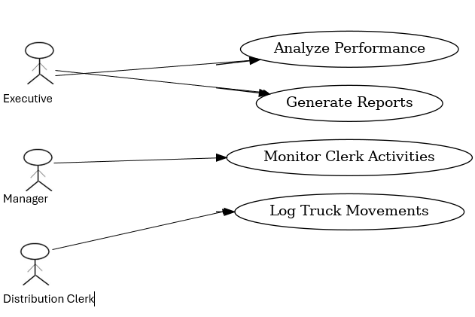

Figure 3: Use Case diagram

### System Architecture Diagram

The system architecture diagram provides a high-level view of the overall structure of the platform. It shows the main components of the system and their interactions.

* Client-side – This includes the web interface (used by the distribution staff, managers and executives) which interacts with the server-side components,
* Server-side – The backend server handles requests from the frontend, processes them and communicates with the database to fetch or store data.
* Database – The database stores all the logistics data, including truck movements, routes, product dispensation, logs and reports. It serves as the data repository for all users and system components.
* Analytics Engine – This component analyses the logistics data and generates insights on truck efficiency, clerk performance and other metrics that contribute to KPI calculation.

Figure 4 shows the System architecture diagram for the platform.

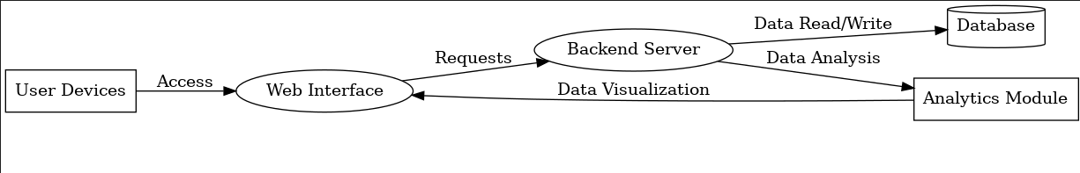

Figure 4: System Architecture Diagram

### Class Diagram

A key modelling tool used in almost all object-oriented approaches is the class diagram. It is a type of UML (Unified Modelling Language) diagram that represents the static structure of a system by showing its classes, their attributes, methods, and relationships. It is widely used in object-oriented design to visually model the design of software systems. The class diagram is a modelling technique that describes the types of objects in the system and the relationships that exist between them. It shows the structure of the system in terms of classes, their attributes, methods and relationships.

* Classes – objects in the system. In this case our classes are User, Driver, Route, Data Log, Report, Analytics.
* Attributes – These are data fields within each class. For instance, the driver class has attributes such as plate number and capacity.
* Associations – These are lines connecting the classes and indicate the relationship between classes. Figure 5 shows the class diagram for the platform

Table 2: Class diagram key

|  |  |
| --- | --- |
| Symbol | Representation |
|  | User: Roles of users and other systems. |
|  | Association: Sequence of actions between users and a use case. |
| 1, * | Multiplicity: |
|  |  |

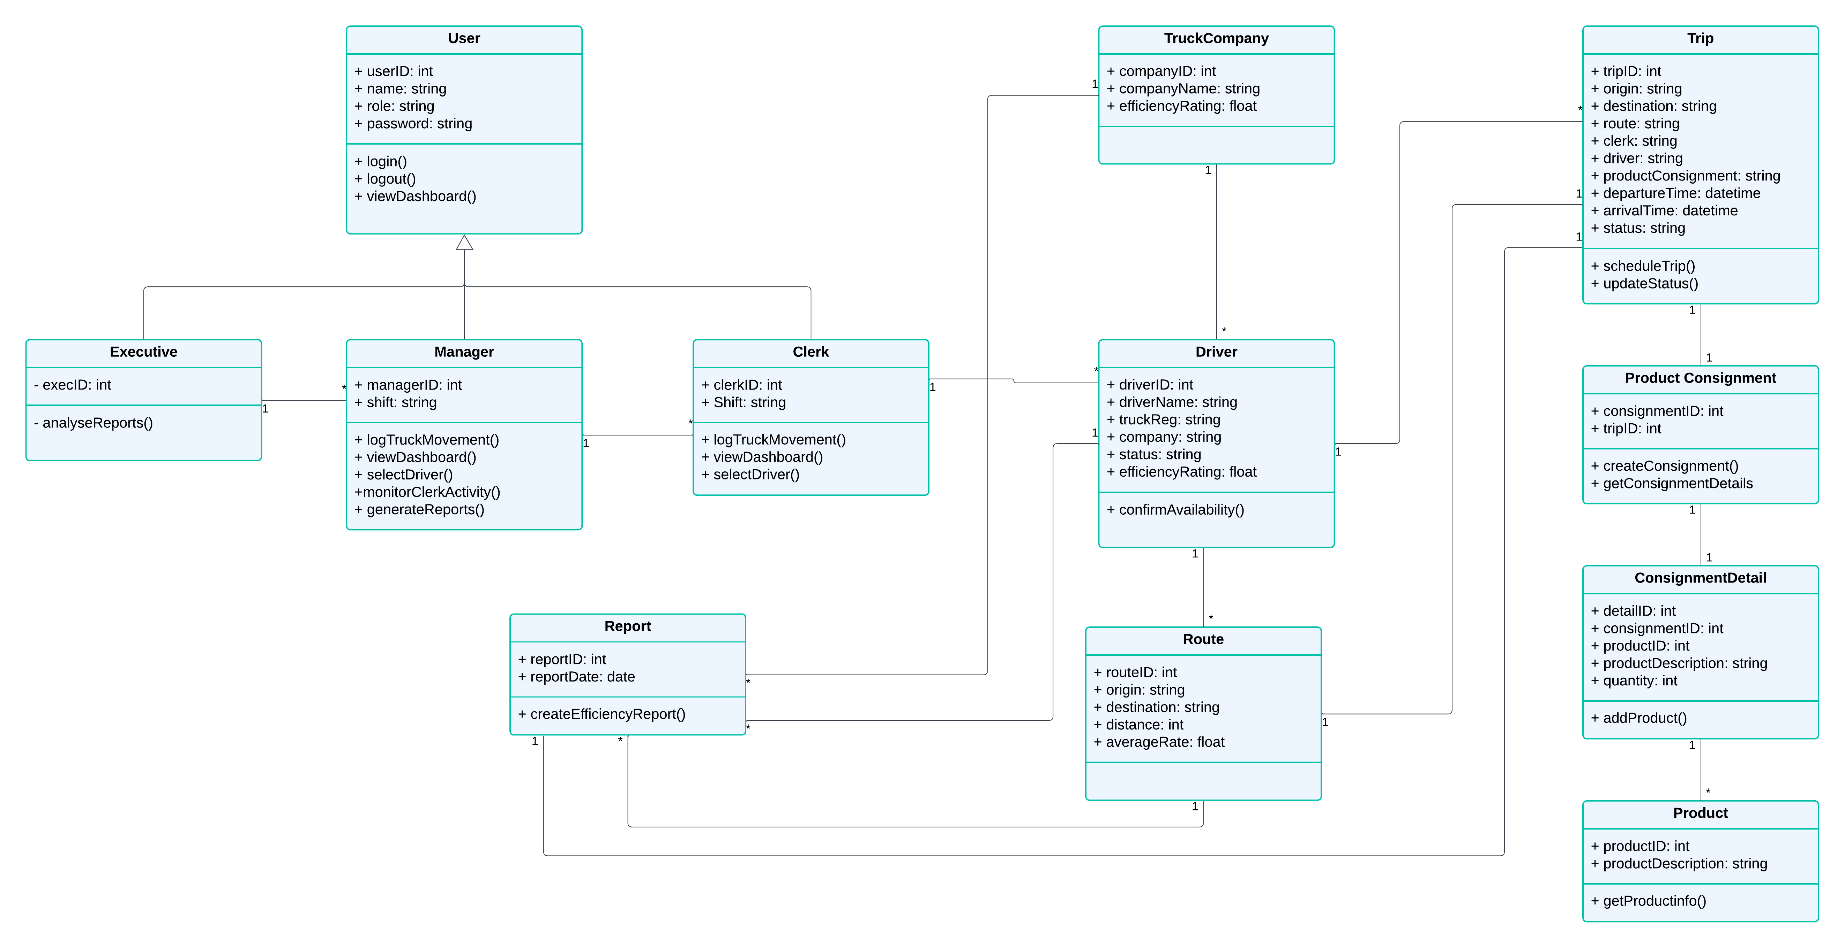

Figure 5:Class Diagram

### Object Diagram

An object diagram is a type of UML diagram that provides a snapshot of the system at a specific point in time. It depicts the instances of classes (objects), their current state (attribute values), and the relationships between them. An object is an instance of a class. The object diagram illustrates these instances of classes, their current state and the relationships between them. As seen on the object diagram on figure 6 below, the user **mmagweregwede** logs in and selects **jdoe**, a truck driver for A1 Trucks to undertake the **Harare-Masvingo** trip. This trip has a product consignment of 50 **5L water bottles**. Once the trip is closed, a report will be generated on how the driver performed.

Table 3:Object diagram key

|  |  |
| --- | --- |
| Symbol | Representation |
|  | User: Roles of users and other systems. |
|  | Association: Sequence of actions between users and a use case. |
| 1, * | Multiplicity: |

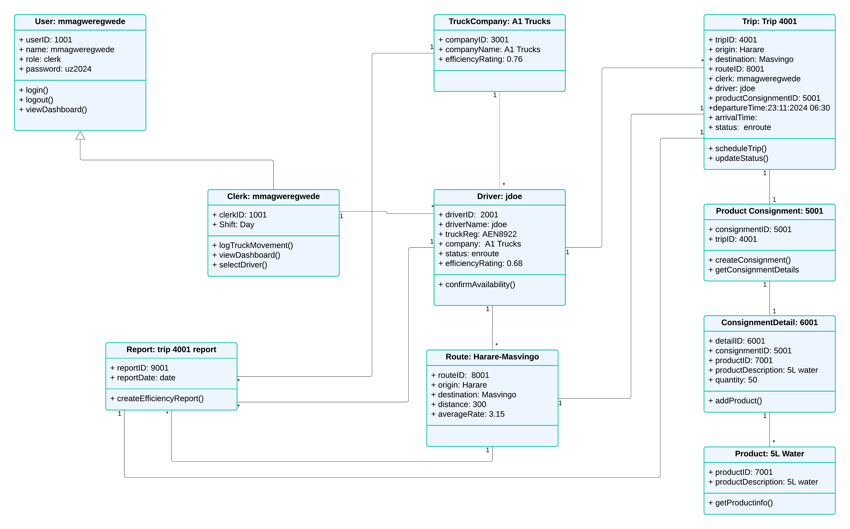Figure 6: Object diagram

### Sequence Diagram

A sequence diagram is an important aspect of UML which helps in the depiction of interaction amongst objects along with their order of occurrence. It highlights object interactions and how they communicate with one another over time. It has become an important modelling tool for characterizing dynamic behaviour of a system. Object interactions, the flow of messages and the order of operations are all depicted with the help of these diagrams. They are consequently very useful in the understanding of use cases, designing system architecture and documenting complex processes. Figure 7 below illustrates a sequence diagram for this application.

Table 4: Sequence diagram key

|  |  |
| --- | --- |
| Symbol | Representation |
|  | Lifeline – named element that depicts an individual participant in a sequence diagram |
|  | Messages – shows communication between objects in a sequence diagram. |

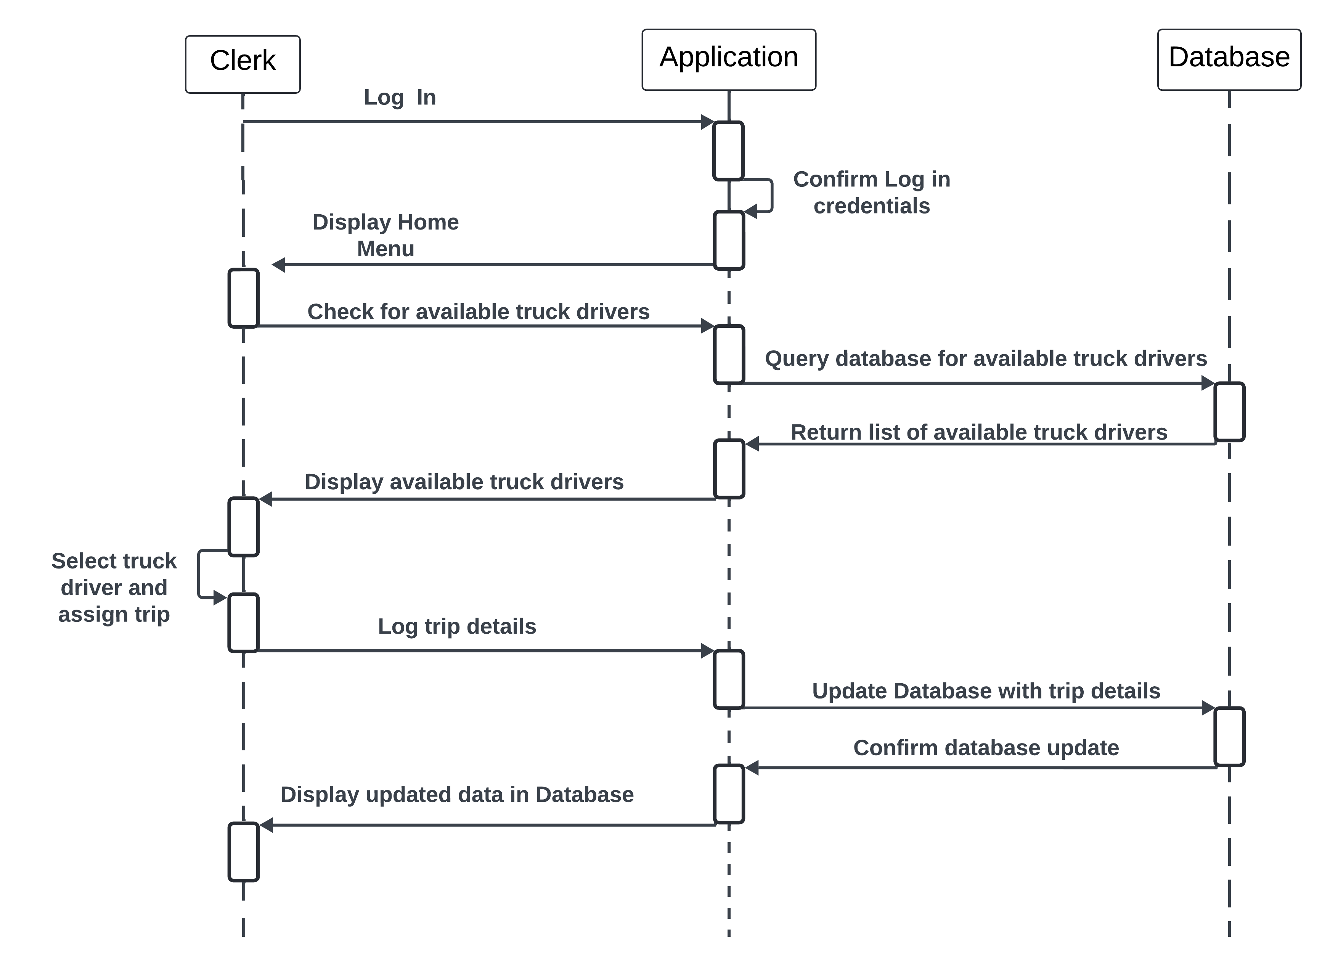

Figure 7: Sequence diagram

### Communication Diagram

A communication diagram is a type of UML diagram that illustrates the interactions between objects in terms of message passing within a system. It focuses on objects and their links rather than the time sequence. Communication diagrams are also known as collaboration diagrams. Figure 8 below shows a communication diagram.

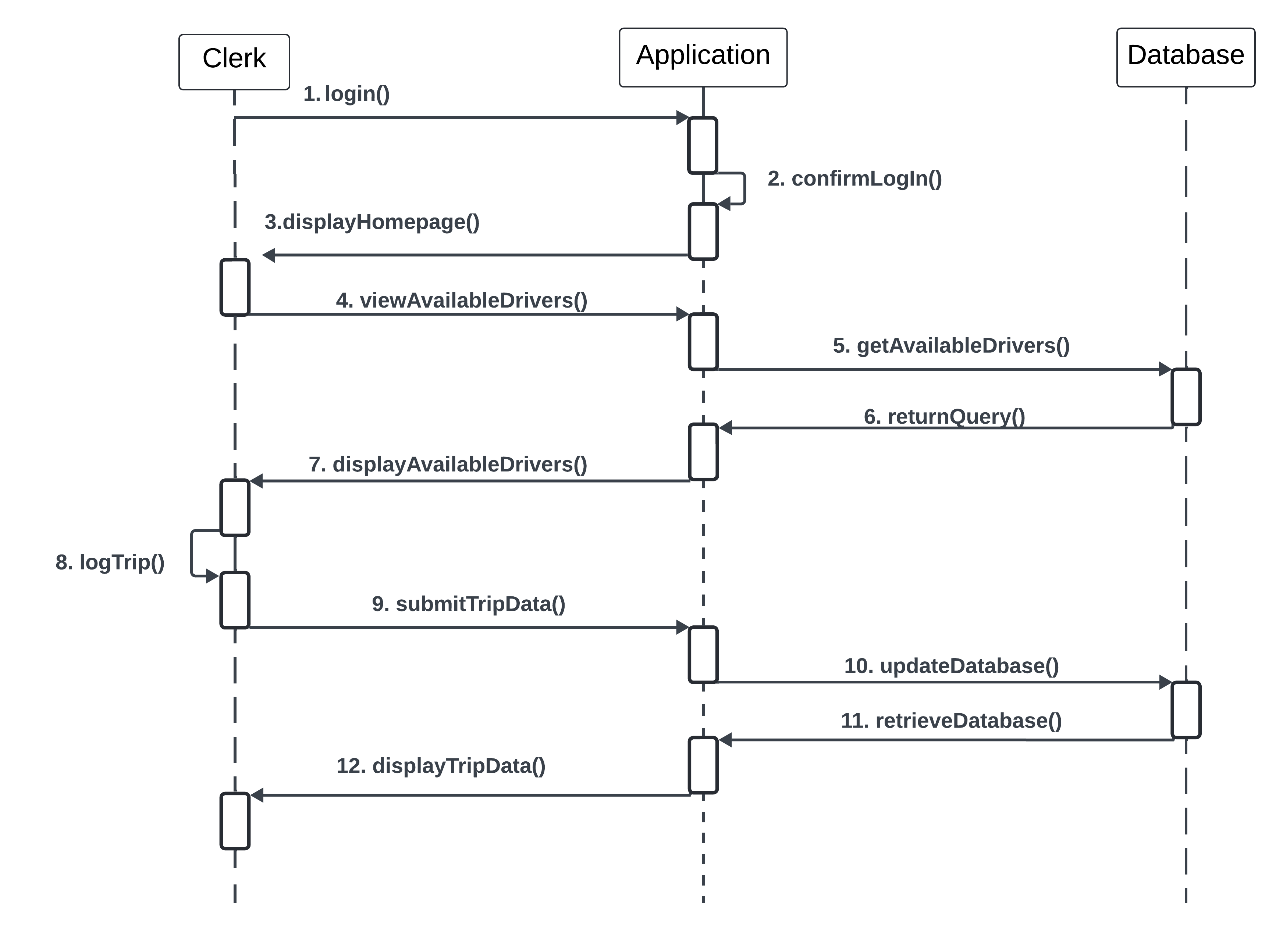Figure 8: Communication diagram

### State Chart Diagram

The state chart diagram describes the flow of control from one state to another. States are defined as a condition in which an object exists, and it changes when some event is triggered (Tutorialspoint, 2019). Figure 9 below represents the state chart diagram for the Truck driver object.

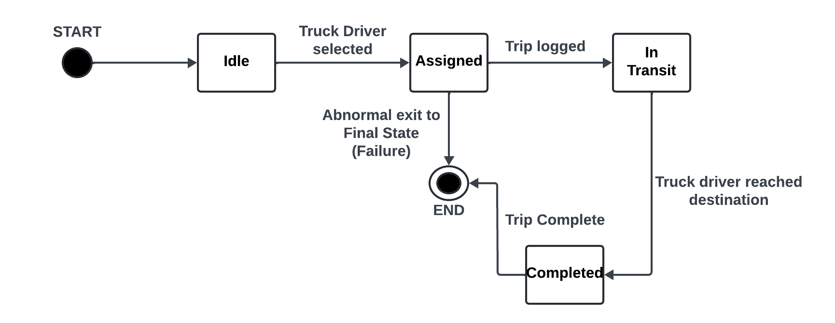Figure 9: Truck driver Object State Diagram

In order for this process to reach completion, the pre-conditions and post-conditions of each state should be true. Otherwise, an abnormal exit to the process is realised. The pre-conditions state conditions that should be true in order for that state to be achieved while the post-conditions state what is achieved by the transition into that state.

#### Pre-conditions

1. Truck driver registered in the system
2. Truck driver has a good efficiency rating

#### Post-conditions

1. Trip is completed and logged.
2. Efficiency rating of the truck driver is updated, based on recent trip.

### Data Flow Diagram

The data flow diagram represents how data moves within the system and between different components. Figure 10 shows the data flow diagram for the platform.

Table 5: Data Flow diagram key

|  |  |
| --- | --- |
| Symbol | Representation |
| External Entity | Actor interacting with the system |
| Process | Action performed by the system |
| Data Store | Storage locations for data |
| Data Flow | Arrow representing the movement of data between processes. |

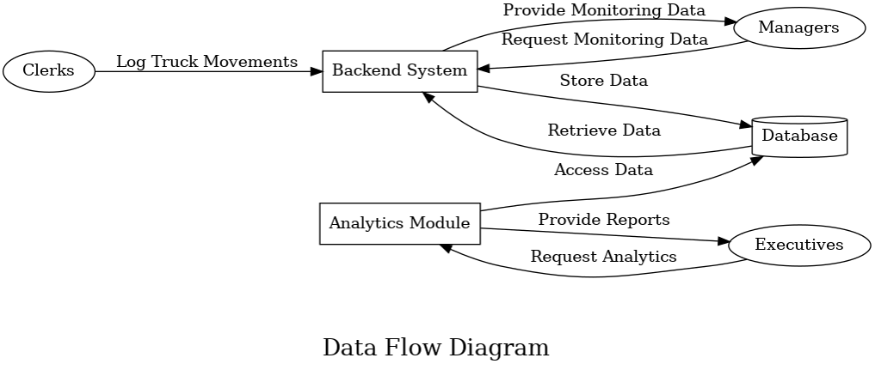

Figure 10: Data Flow Diagram

## Expected Outcomes and Impact

### Success Criteria

The success of the platform will be evaluated based on the following criteria:

#### Functionality and Usability

* Comprehensive Data Logging: The platform must allow distribution staff to log truck movements and product dispensation accurately and in real-time.
* Managerial Oversight Tools: Managers should have intuitive dashboards to monitor clerks' activities effectively.
* Executive Analytics Tools: Executives must have access to actionable insights, such as trucking company efficiency on specific routes supported by data visualizations and reports.
* Real-Time Updates: All stakeholders should have access to up-to-date information on logistics operations.

#### Reliability and Performance

* System Uptime: The platform must maintain 99% uptime to ensure consistent accessibility.
* Scalability: The system must handle concurrent users without performance degradation, accommodating future growth.
* Response Time: Real-time data should be displayed with a delay of no more than 2 seconds.

#### Integration and Interoperability

* Data Import/Export: Ability to export data in commonly used formats such as comma separated value (csv) files that can be viewed with spreadsheet software such as Microsoft Excel.

#### Security and Compliance

* Data Security: Robust measures to protect sensitive logistics data such as encryption, secure user authentication and role-based access.
* Compliance: Adherence to relevant industry standards and local data protection laws such as the Data Protection Act of Zimbabwe.

#### User Adoption and Training

* Ease of Use: Intuitive interface design ensuring minimal learning curve.
* Training Effectiveness: All staff should demonstrate proficiency in using the platform after training.

#### Impact on Logistics Operations

* Efficiency Improvements: Reduction in delays, route deviations and resource wastage.
* Cost Savings: Clear evidence of cost optimization in logistics operations.
* Decision-Making: Improved accuracy and timeliness of executive decisions based on data insights.

#### Stakeholder Feedback

* Positive feedback from all user groups (distribution staff, managers, and executives) in post-implementation surveys.

### Impact

#### Operational Efficiency

The platform will streamline logistics operations by providing real-time visibility into truck movements, product dispensation and logistics costs. This will reduce delays and inefficiencies, ensuring products are delivered to their destinations on time.

#### Enhanced Decision-Making

Business executives will have access to critical data and insights, enabling informed decisions such as selecting the most efficient trucking company or reallocating resources to improve logistics performance.

#### Cost Optimization

The platform will identify areas of inefficiency such as underperforming routes or excessive idle time, enabling time and cost saving measures in logistics management.

#### Improved Accountability

The ability to monitor clerks and truck movements will improve accountability, reduce operational inefficiencies and ensure adherence to organizational policies.

#### Scalability and Competitiveness

By adopting cutting-edge logistics technology, Schweppes Zimbabwe will position itself as a leader in the industry, enhancing its ability to scale operations and remain competitive.

## Conclusion

This chapter focused on the hardware and software components used in the system as well as the requirements of the platform. The mixed approach was implemented as the research methodology and the incremental development cycle selected as the design methodology. The research methodological approach ensures that the platform is both data-driven and user-centred, meeting the functional needs of the distribution staff, managerial requirements for oversight and executive demands for strategic logistics planning. The subsequent incremental development methodology is ideal for creating a real-time logistics data management and analytics platform for Schweppes Zimbabwe. It offers flexibility, faster time to market, and the ability to adapt to evolving user needs. The platform will serve as a model for other companies in Zimbabwe, demonstrating the value of leveraging technology for logistics management. This could inspire industry-wide adoption of similar systems, driving modernization and efficiency across the logistics sector. By meeting the outlined success criteria and achieving impacts, the platform will not only address the specific needs of SZL but also contribute meaningfully to advancements in logistics management.

## References

1. Abadi, M., Agarwal, A., Barham, P., Brevdo, E., Chen, Z., Citro, C., Corrado, G.S., Davis, A., Dean, J., Devin, M., Ghemawat, S., Goodfellow, I., Harp, A., Irving, G., Isard, M., Jia, Y., Jozefowicz, R., Kaiser, L., Kudlur, M. and Levenberg, J. (2016). *TensorFlow: Large-Scale Machine Learning on Heterogeneous Distributed Systems*. [online] arXiv.org. Available at: https://arxiv.org/abs/1603.04467.Alder, P., & Sidhu, S. (2020). Advances in Logistics Analytics and Data Management. McGraw-Hill.
2. Baskerville, R., & Myers, M. D. (2015). Design ethnography in information systems. *Information Systems Journal*, 25(1), 23–46.
3. Bechtsis, D., Tsolakis, N., Vlachos, D. and Srai, J. S. (2021). Intelligent autonomous vehicles in digital supply chains: A framework for integrating real-time data-driven capabilities. *Computers & Industrial Engineering*, 157, p.107329.
4. Berfield, A. (2018). "Evaluating Cloud-Based TMS for Small Business Logistics," Logistics Today, 32(4), 45–52.
5. Bhimani, A. (2019). 'Data analytics and the future of management accounting', *Journal of Management Accounting Research*, 31(1), pp. 1-10
6. Bostock, M. (2013). *D3.js - Data-Driven Documents*. [online] D3js.org. Available at: https://d3js.org/.
7. Cao, F., Ester, M., Qian, W., & Zhou, A. (2003). Clustering Stream Data in a Data Stream Environment, Proceedings of the 2003 SIAM International Conference on Data Mining, pp. 281-292.
8. C.H. Robinson (2019). Navisphere: A transportation management solution. Retrieved from <https://www.chrobinson.com/en-us/>
9. Chen, M., Li, J., & Wang, H. (2019). "Comprehensive Analysis of Modern Transportation Management Systems," Journal of Logistics Research, 15(2), 121–139.
10. Christopher, M. (2016). *Logistics & Supply Chain Management*. 5th ed. Harlow, United Kingdom: Pearson Education.
11. Davenport, T. H. (2013). *Analytics at Work: Smarter Decisions, Better Results*. Harvard Business Review Press.
12. Davis, F. D. (2019). Perceived usefulness, perceived ease of use, and user acceptance of information technology. MIS Quarterly, 13(3), 319-340.
13. Deloitte. (2021). Supply Chain and Logistics Trends 2021. Deloitte Insights.
14. Descartes. (2022). Descartes MacroPoint Solutions. Retrieved from <https://www.descartes.com/>
15. Django (n.d.). *The Web framework for perfectionists with deadlines | Django*. [online] Djangoproject.com. Available at: https://www.djangoproject.com/.
16. Fiveable.me. (2024). *Data analytics - Vocab, Definition, and Must Know Facts | Fiveable*. [online] Available at: https://library.fiveable.me/key-terms/criminal-justice/data-analytics [Accessed 18 Sep. 2024].
17. Flexport (2020). Flexport’s technology for global logistics. Retrieved from <https://www.flexport.com/>
18. FourKites (2021). Real-time visibility for freight and logistics. Retrieved from <https://www.fourkites.com/>
19. Frankenfield, J. (2023). *Data analytics: What it is, how it’s used, and 4 basic techniques*. [online] Investopedia. Available at: <https://www.investopedia.com/terms/d/data-analytics.asp>.
20. Freightview. (2023). Freightview TMS Overview. Retrieved from <https://www.freightview.com/>
21. Håkansson, H., & Snehota, I. (2017). *No business is an island: Making sense of the interactive business world*. Emerald Publishing Limited.
22. Harrison, A. and van Hoek, R. I. (2011). *Logistics Management and Strategy: Competing through the Supply Chain*. 3rd edn. Harlow: Pearson Education.
23. Ivanov, D. and Alexandre Dolgui (2020). A digital supply chain twin for managing the disruption risks and resilience in the era of Industry 4.0. [online] ResearchGate. Available at: <https://www.researchgate.net/publication/341542060_A_digital_supply_chain_twin_for_managing_the_disruption_risks_and_resilience_in_the_era_of_Industry_40>
24. Kang, D., Park, J. and Kim, Y. (2020). The role of automation in the future of lean logistics. *International Journal of Logistics Research and Applications*, 23(4), pp.335-350.
25. Kim, H., Sanz, J.L. & Wang, T. (2019). 'Mobile applications in logistics for real-time tracking and data logging', Journal of Operations and Control Management, 4(2), pp. 87-96. Available at: https://doi.org/10.1016/j.jocm.2019.10.008.
26. Kroenke, D.M. and Boyle, R.J. (2017). *Using MIS*. New York, Ny: Pearson.
27. Kumar, A. and Singh, R. (2019). 'The role of big data in supply chain management: A review', *International Journal of Supply Chain Management*, 8(4), pp. 102-112.
28. Lewis, W.E. (1999). Software Testing and Continuous Quality Improvement. Boca Raton, FL: CRC Press.
29. Liu, X., Zhang, Y. and Sun, H. (2022). Logistics automation in developing countries: Challenges, solutions, and impacts. *Sustainability*, 14(9), p.5324.
30. Mentzer, J. T., Min, S. and Bobbitt, L. M. (2001). 'Toward a unified theory of supply chain management', *Journal of Business Logistics*, 22(2), pp. 1-25.
31. Nielsen, J. (1993). *Usability Engineering*, San Diego: Academic Press.
32. Norman, D. A., & Draper, S. W. (1986). *User centered system design: New perspectives on human-computer interaction*. Lawrence Erlbaum Associates.
33. Oracle (2020). Oracle Transportation Management: Platform features. Retrieved from <https://www.oracle.com>
34. Pedregosa, F., Varoquaux, G., Gramfort, A., Michel, V., Thirion, B., Grisel, O., Blondel, M., Prettenhofer, P., Weiss, R., Dubourg, V., Vanderplas, J., Passos, A., Cournapeau, D., Brucher, M., Perrot, M. and Duchesnay, E. (2011). Scikit-Learn: Machine Learning in Python. Journal of Machine Learning Research, 12, 2825-2830.
35. plotly.com. (n.d.). *Modern Analytic Apps for the Enterprise - Plotly*. [online] Available at: https://plotly.com/.
36. Popovic, A., Hackney, R., Coelho, P.S. & Jaklic, J. (2014). 'Towards business intelligence systems success: Effects of maturity and culture on analytical decision making', *International Journal of Production Economics*, 142(1), pp. 125-133. Available at: https://doi.org/10.1016/j.ijpe.2014.01.013.
37. Project44. (2022). Real-Time Visibility and Tracking Solutions for Logistics. Project44 White Paper.
38. Ramirez, G., Atienza, D., & McIntire, D. (2018). 'Cloud computing for logistics management', IEEE Cloud Computing, 5(3), pp. 50-58. Available at: <https://doi.org/10.1109/MIC.2018.2881527>.
39. Rimal, B.P., Choi, E. & Lumb, I. (2009). 'A taxonomy and survey of cloud computing systems', IEEE Computer, 43(8), pp. 50-56. Available at: https://doi.org/10.1109/MC.2009.306.
40. SAP. (2022). SAP Transportation Management Overview. SAP SE.
41. *Schweppes Holdings Africa Limited*. [online] Available at: <https://www.schweppes.co.zw/>
42. Segel, E., and Heer, J. (2010). *Narrative Visualization: Telling Stories with Data.* IEEE Transactions on Visualization and Computer Graphics
43. Singh, R. (2021). "Challenges and Solutions in ERP-Integrated TMS Systems," International Journal of Supply Chain Management, 24(1), 89–98.
44. Tutorialspoint (2019). UML - Statechart Diagrams - Tutorialspoint. [online] Tutorialspoint.com. Available at: <https://www.tutorialspoint.com/uml/uml_statechart_diagram.htm>.
45. Wang, Y., Gunasekaran, A. and Ngai, E. W. T. (2016). 'Big data in logistics and supply chain management: B2B and B2C perspectives', *Journal of Supply Chain Management*, 52(2), pp. 44-53.
46. Williamson, O.E. (1981). The Economics of Organization: The Transaction Cost Approach. *American Journal of Sociology*, 87(3), pp.548–577.
47. Womack, J. and Jones, D. (1996). *Lean Thinking : Banish Waste and Create Wealth in Your Corporation*. [online] ResearchGate. Available at: <https://www.researchgate.net/publication/200657172_Lean_Thinking_Banish_Waste_and_Create>
48. Yu, L., Ma, X. and Sun, Z. (2021). Exploring the impacts of real-time logistics data on supply chain efficiency: A case study. *Journal of Business Logistics*, 42(1), pp.56-70.
49. Zhong, R.Y., Xu, X. and Klotz, E. (2017). Smart manufacturing with IoT-enabled big data services. *Robotics and Computer-Integrated Manufacturing*, 45, pp.86-99.Top of Form
50. Zikmund, W. G., Babin, B. J., Carr, J. C., & Griffin, M. (2013). *Business research methods*. Cengage Learning.Top of Form